**INSTRUCTIONS:** This is a sample handout intended to be distributed to research participants wearing the Visual Environment Evaluation Tool (VEET) device.

* Researchers may customize the first page of this handout (and remove these instructions highlighted in yellow) according to the parameters of their study and per their IRB’s guidance.
* Researchers must distribute **Appendix A: Visual Environment Evaluation Tool Health & Safety Information** without modification.

The Visual Environment Evaluation Tool (VEET) Research Participant Instructions

___________________________________________________________

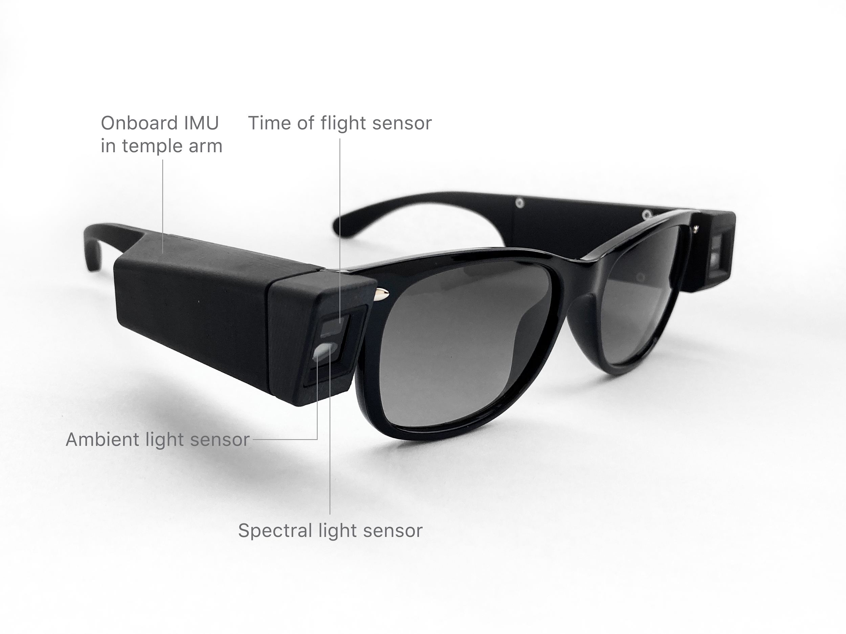

***VEET Sensors*** *(right temple arm)*

**CAUTION**

* Do not use the VEET during activities where use may create a safety hazard or potentially cause damage to the VEET such as during water-based activities, activities requiring the use of a helmet or other sports or safety gear, or while driving or in other situations where full, unobscured vision is required.
* Do not attempt to charge your VEET from a computer or a USB hub.
  1. **DIRECTIONS FOR USE**

1. Wear the VEET while performing your usual daily activities
2. Charge each VEET temple arm every night
   * Use 2 USB-C chargers with either USB-C type A or C cable connected to wall power
     + Both the red LED and the white LED turn on for 5 seconds, alternating from red to white.
   * Make sure the temple arms are uncovered and in the same room where you sleep, so it can gather information about light in your sleeping environment

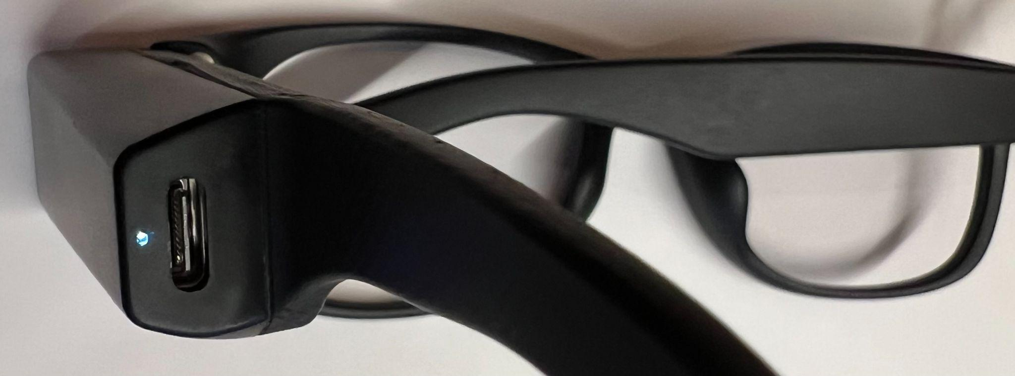

***VEET White LED***

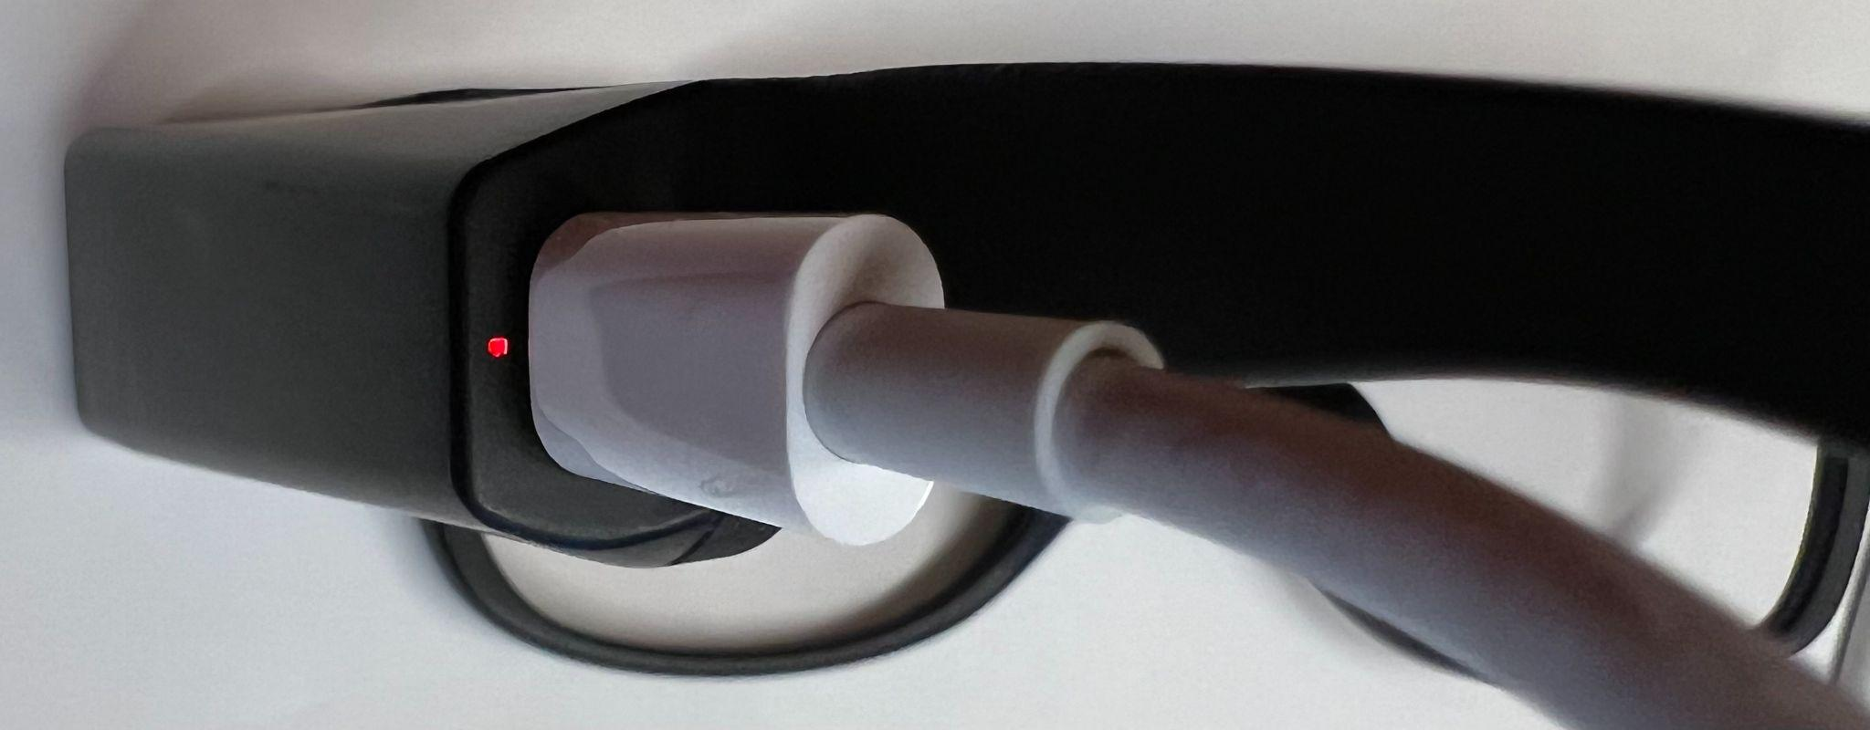

***VEET Red LED***

* 1. **PRIVACY-CENTERED DESIGN**

To protect your privacy and safety, the VEET has no cameras, no microphones, and no wireless or cloud connectivity.

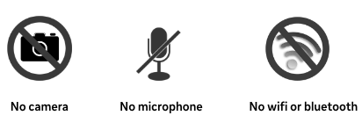

# 

# Appendix A

**Visual Environment Evaluation Tool Health & Safety Information**

## 

**RESEARCH PROTOTYPE. NOT INTENDED FOR SALE OR GENERAL DISTRIBUTION.**

This device has not been authorized as required by the rules of the Federal Communications Commission. This device is not, and may not be, offered for sale or lease, or sold or leased, until authorization is obtained.

This product may not be placed on the market or put into service until it has been made to comply with local law, including laws in the EU, UK and Switzerland if the device is in use in these jurisdictions.

* + 1. **California Proposition 65 Warning**

WARNING: This product contains nickel, which is known to the State of California to cause cancer. For more information go to [www.P65Warnings.ca.gov](http://www.p65warnings.ca.gov/).

| ⚠️**WARNING: Read and follow all provided health and safety information to reduce risk of personal injury, discomfort or property damage** |
| --- |

### **Intended Users & Uses**

**Non-consumer use only**. The Visual Environment Evaluation Tool (“VEET”; includes temple arms and provided charging accessories, if any), as currently designed, is intended for limited distribution for research and data collection purposes only and is not intended for sale or distribution. Not for use with young children.

**⚠️WARNING:** Choking hazard—Small parts. Keep away from children under 3 years.

**Unsafe Use**. Do not use the VEET during activities where use may create a safety hazard or potentially cause damage to the VEET such as during water-based activities, activities requiring the use of a helmet or other sports or safety gear, or while driving or in other situations where full, unobscured vision is required.

### **Discomfort & Other Conditions**

**Skin Reactions**. Wearable products that have prolonged contact with the skin may result in skin reactions due to interactions with certain materials, external irritants (e.g., soap, sweat, or lotion/sunscreen), or other environmental factors. To avoid skin reactions, follow all provided cleaning and care instructions and take breaks from wearing the VEET. Stop use if pressure, chafing, itching, irritation, lasting changes in skin appearance, swelling, unusual hair loss, or other skin discomfort arises. Check fit and cleanliness as symptoms may resolve after adjusting/cleaning. Stop use and consult a doctor if symptoms continue.

**Laser safety.** Do not hack, tamper, attempt to repair, modify, override programming for, disassemble, or alter the drive/safety circuit or install additional components inside the VEET. If the VEET is exposed to liquid or is mechanically damaged, please stop use immediately.

* + 1. 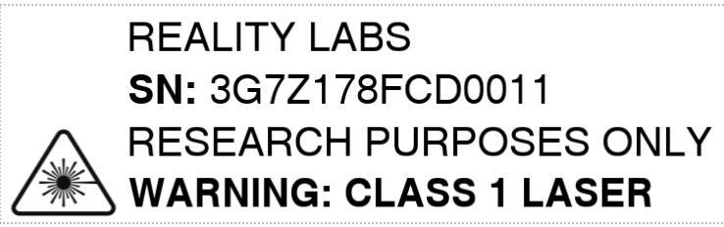

This device contains a Class 1 laser. Use other than as described in the user guide, repair, or disassembly may cause damage, which may result in hazardous exposure to infrared emissions that are not visible. This equipment may only be serviced by Meta.

* + 1. NOTE: This device complies with FDA performance standards for laser products except for conformance with IEC 60825-1 Ed. 3., as described in Laser Notice No. 56, dated May 8, 2019.

### 

### **Electrical Safety**

**Charging**. Follow all provided charging instructions. Improperly charging may permanently damage the VEET and increase the risk of injury or property damage. Use only provided charging accessories. Keep the charging ports clear of debris, moisture, and residue using the provided cleaning and care instructions.

* Do not wear or clean the VEET while charging.
* Periodically inspect the VEET including charging accessories for damage or signs of wear.
* If any part is damaged or cracked or any internal component is exposed, stop using or charging immediately.
* Do not use the VEET or continue charging attempts if the VEET does not power on after attempted charging.

**Overheating**. It is normal for the VEET to feel warm to the touch while in use or while charging; however, if the VEET feels hot to the touch, stop using or charging immediately and allow the VEET to cool down. Prolonged skin contact when hot may produce discomfort, redness, or low-temperature burns. Do not leave the VEET in direct sunlight or expose to excessive heat or fire.

**Approved Accessories Only.** Using non-approved accessories or spare parts may permanently damage the VEET and increase the risk of injury or property damage.

### **Battery Safety**

The VEET contains lithium-ion batteries that are not user-replaceable. Special care should be exercised when handling the battery or charging accessories. If proper handling procedure and these instructions are not followed, the internal lithium ion battery may present a risk of explosion, fire, burn, electrolyte leakage or injury to the user or others, or damage to the device or other property.

* Do not remove or attempt to remove the battery
* Do not expose the VEET to fire or expose to or soak in water or other liquids
* Do not touch, disassemble, puncture, crush, bend, or damage the battery
* Avoid dropping the VEET. Dropping the VEET, especially on a hard surface can potentially cause damage that can result in increased risk of injury or property damage.
* Do not use or charge the VEET if you know or suspect it is damaged, will not turn on after attempted charging, it gets abnormally warm when used or charged, or if the battery compartments are swollen, leaking liquid or smoking.
* In the event of a battery leak, do not allow the liquid to come in contact with the skin or eyes. If contact has been made, wash the affected area with large amounts of water and seek medical advice.

### **Handling & Maintenance**

**Handle with care and avoid damage.** The VEET is sensitive electronic equipment and should be handled with care.

* Do not disassemble, crush, bend, deform, puncture, shred, or put a high degree of pressure on the VEET.
* Do not drop, strike, or shake the VEET excessively.
* Do not use the VEET if damaged.
* Do not attempt to open, disassemble, repair, or tamper with the VEET. Touching internal components could result in injury.

**Keep the VEET Clean and Dry**. Clean the VEET between uses and users to avoid possibly transferring a contagious condition. Keep the VEET and charging accessories away from any liquids, including sunscreen and lotion. The VEET is not designed to resist submersion, or extended exposure to liquids, which could cause property damage or injury. Use only approved cleaning solutions.

**Store the VEET as instructed**. Do not place VEET in high-temperature locations or environments, such as on or near a cooking surface, cooking appliance, iron, radiator, direct sunlight, or extended periods inside a car.

**Potentially explosive atmospheres.** Do not use, charge, or store with explosive materials or in any area with a potentially explosive atmosphere.